Kuruyu wa 20/10/2013
abahanzi b`i Muhanga bakorera umuziki wabo muri studio ya touch light music bafatanyije n`abakora umwuga w`itangazamakuru mu rwego rwo kurwanya ibiyobyabwenge murubyiruko bakinnye umukino wa gicuti mu mupira w`amaguru nikipe yitwa The Genius nayo y`i Muhanga aho abanyamakuru bafatanyije n`abahanzi batsinze ikipe ya the Genius ibitego 3 by`abahanzi n`abanyamakuru kuri 2 bya The genius abayobozi bakaba bishimiye icyo gikorwa .
Reba amafoto hano uko byari byifashe.
AHA NI MBERE YUKO UMUKINO UTANGIRA IKIPE Y`ABANYAMAKURU N`ABAHANZI BARI KWISHYUSHYA.
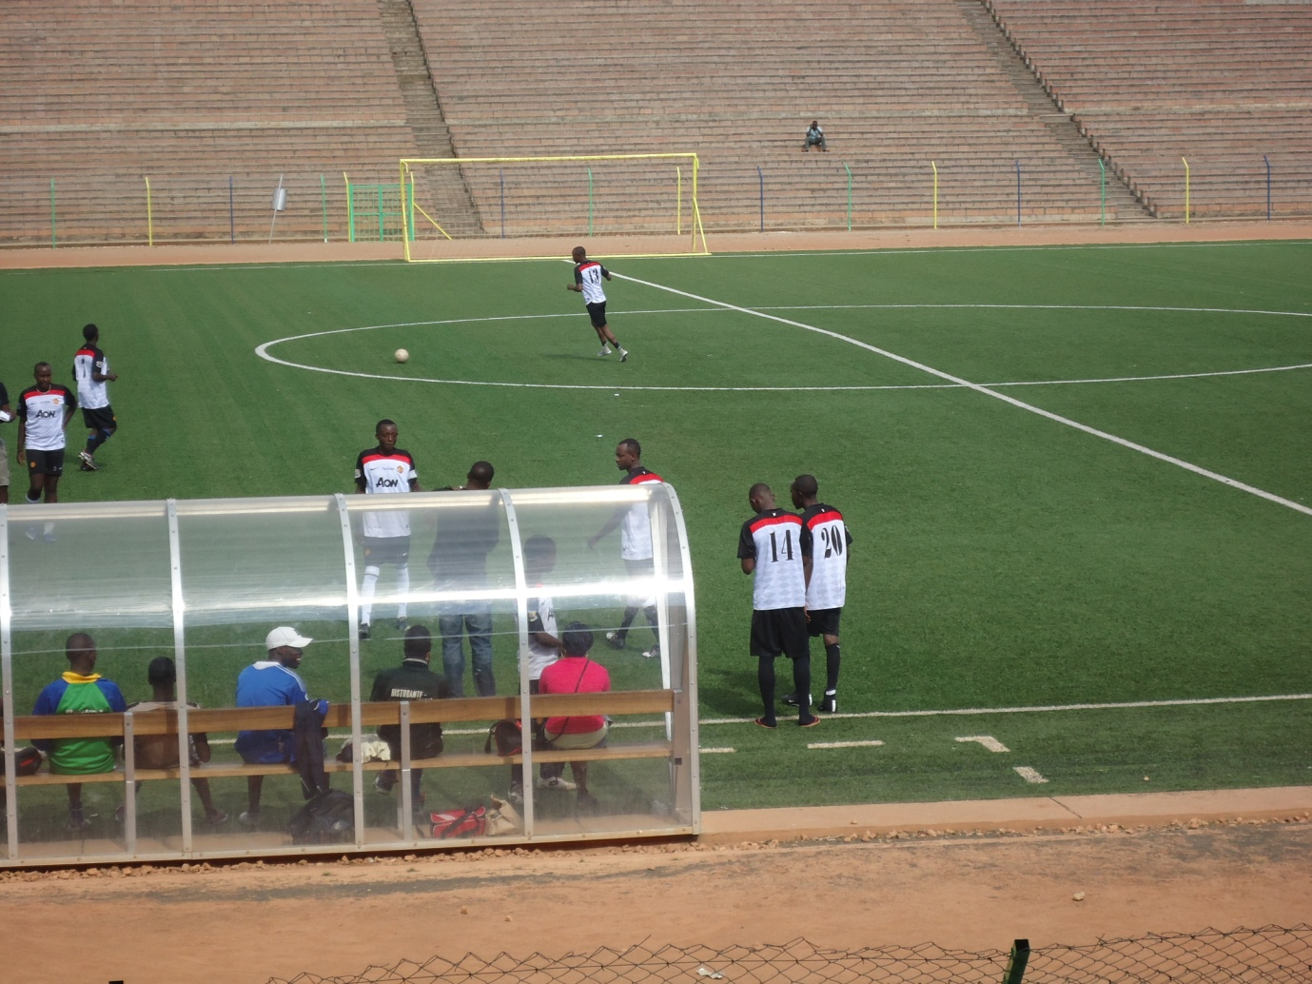

IYI NAYO NI THE GENIUS MBERE YUKO MATCH ITANGIRA
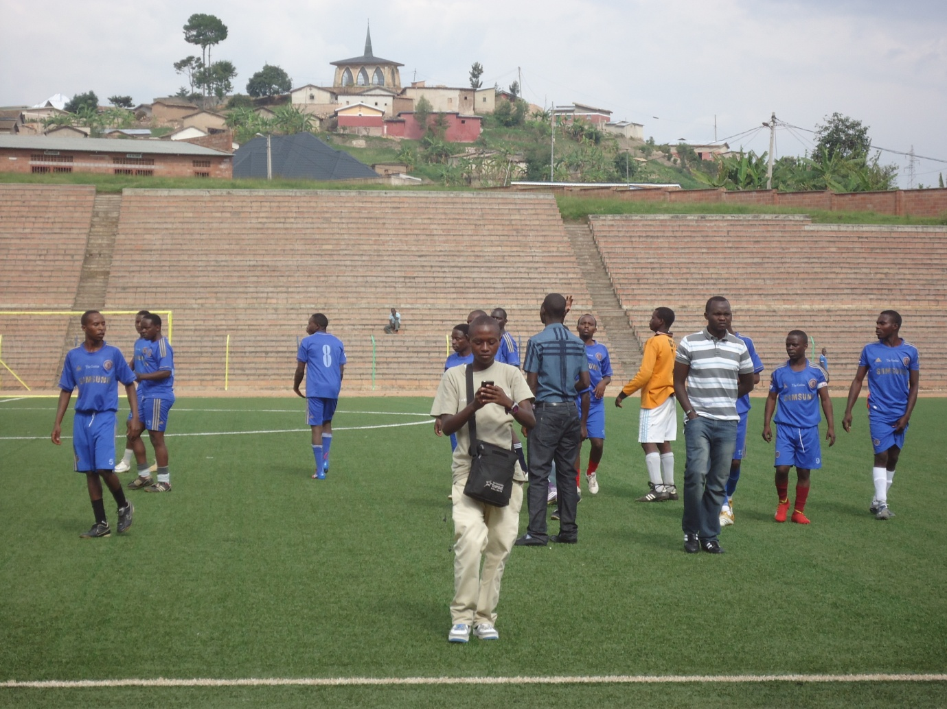

NGIKI IGIKOMBE CYAHATANIRWAGA NAYO MAKIPE GITERETSE IMBERE YUWAJE AHAGARARIYE POLICE
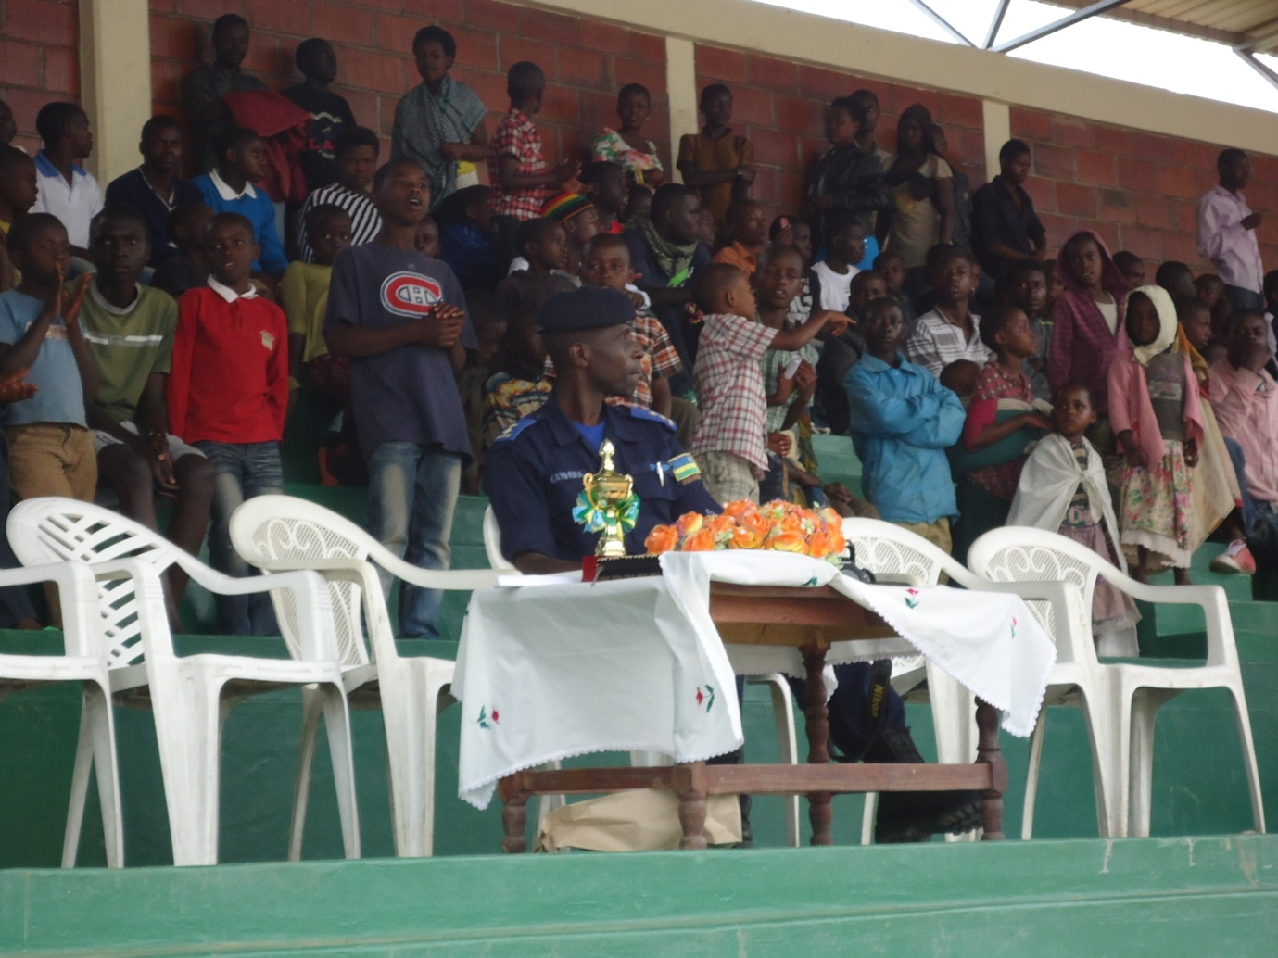

UYU NAWE NUWARI WAJE AHAGARARIYE GEREZA YA MUHANGA AKABA ARI NUMUHANZI
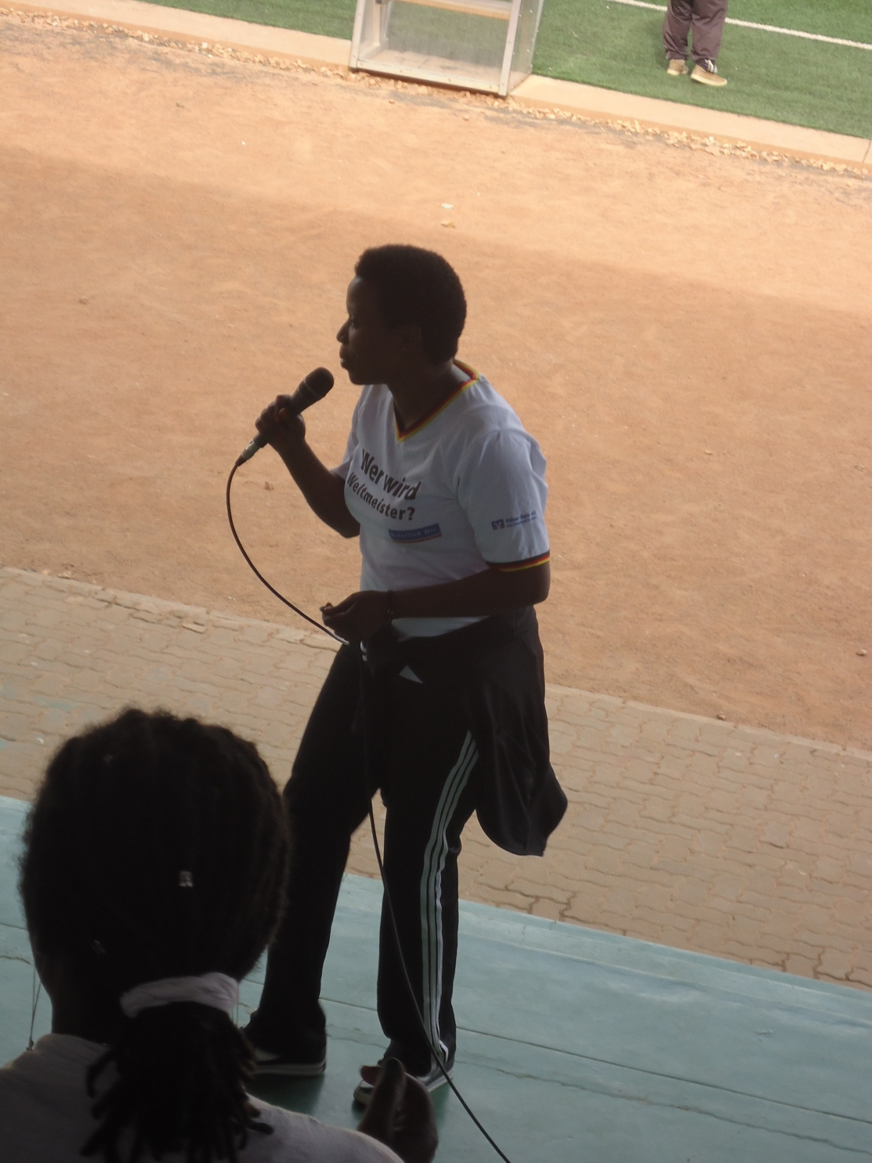
DORE UBURYO UBUYOBOZI NABWO BWASHIMYE ABO BAHANZI MURI ICYO GIKORWA.
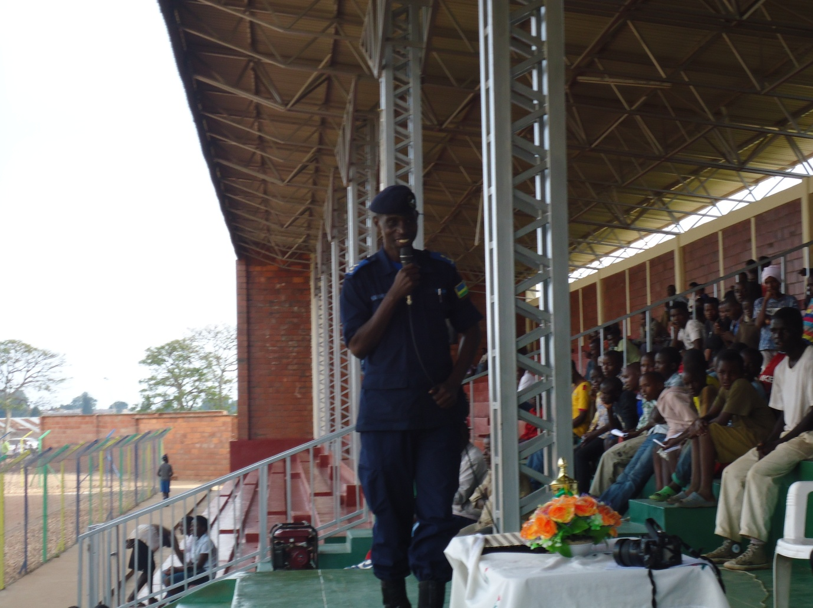

ABA N`ABAHANZI BARI KURIRIMBA INDIRIMBO IKANGURIRA URUBYIRUKO KUREKA IBIYOBYABWENGE.
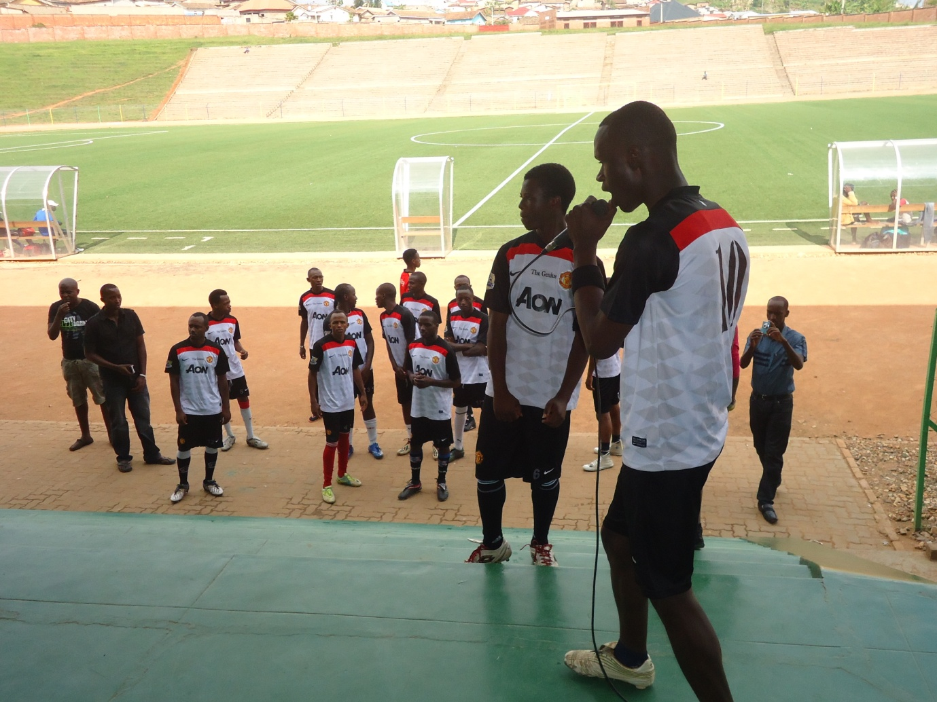

UYU NI JOSHUA KAGGWA (JOSH 87) UHAGARARIYE ABAHANZI BAKORERA MURI TOUCH LIGHT MUSIC STUDIO ARIKUMWE NABAYOBOZI MBERE YUKO UMUKINO UTANGIRA.
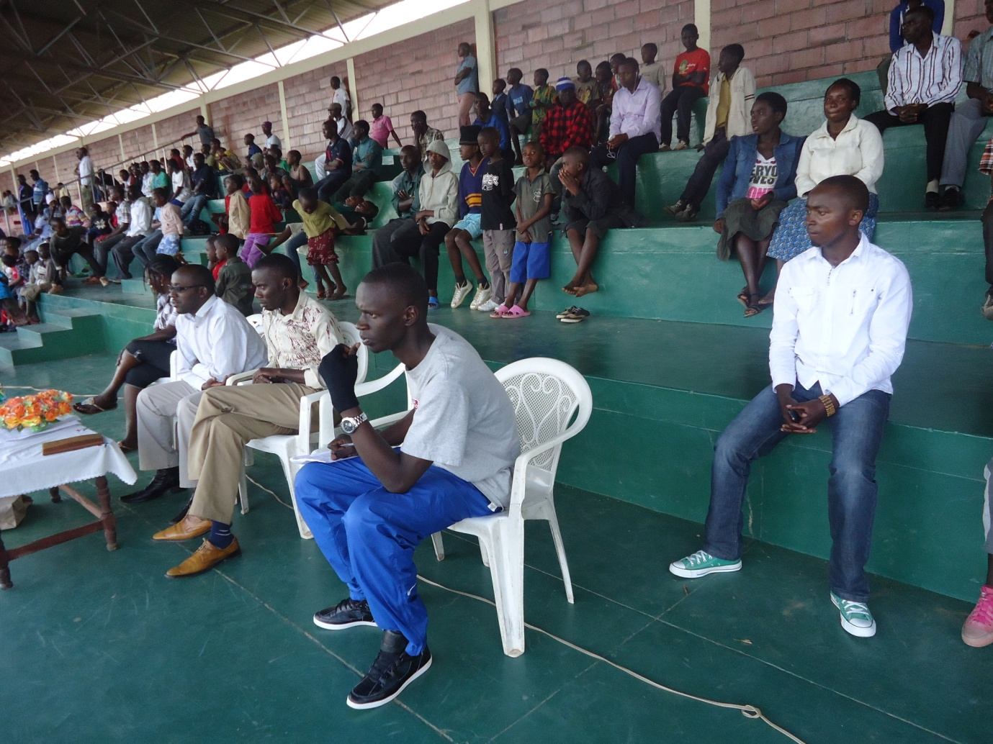

ABA NI ABATOZA BA TOUCH LIGHT MUSIC F.C(YVES NA ALAIN) BAJYA INAMA
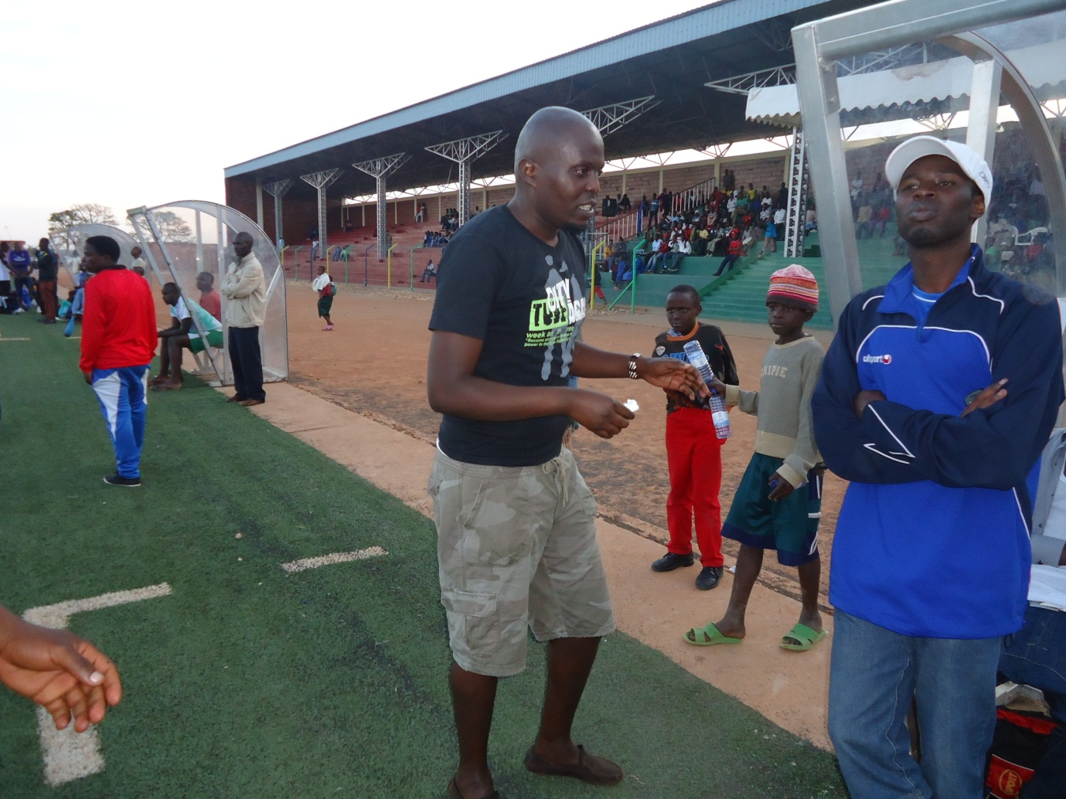

AHA NI CAPITAINE WA TOUCH LIGHT MUSIC F.C CLAUDE FRANK IBAKWE YAKIRA IGIKOMBE,AKABA YAGISHYIKIRIJWE N`UWARUHAGARARIYE UBUYOBOZI BW`UMURENGE WA NYAMABUYE,AKABA YAHISE
ANAGISHYIKIRIZA UMUYOBOZI WA TOUCH LIGHT MUSIC STUDIO.
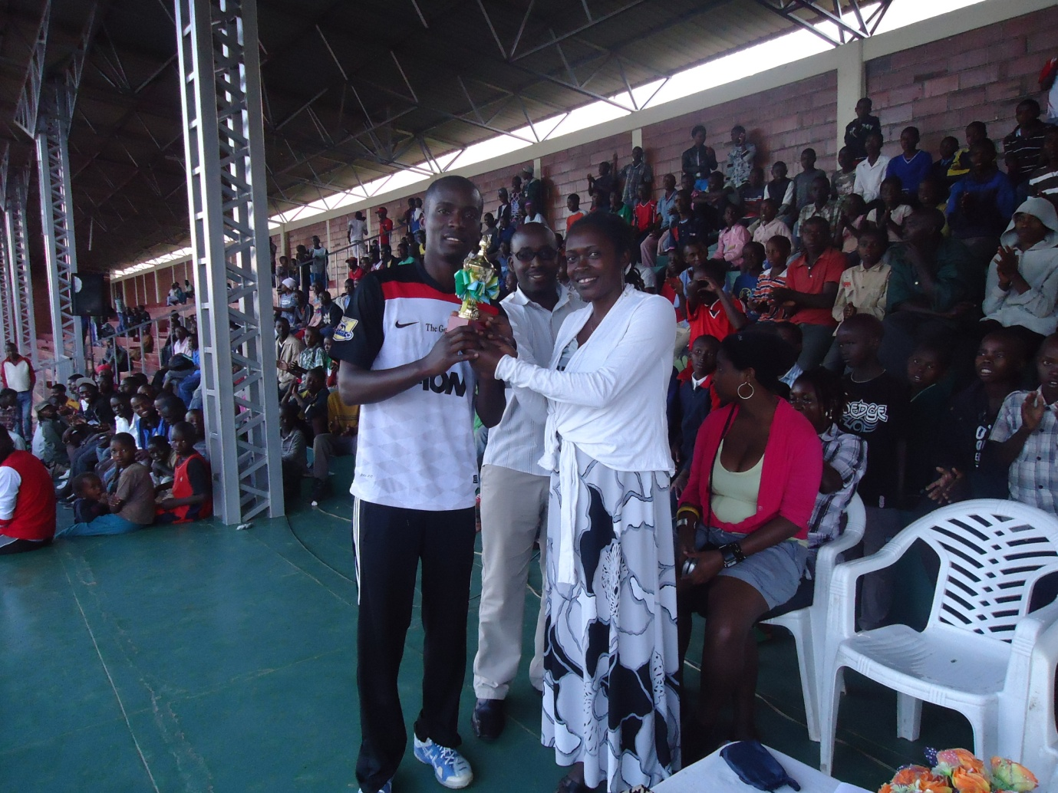
NGUKO UKO UMUKINO W`IGIKORWA CYAKOZWE N`ABAHANZI BISHYIZE HAMWE BAKORERA MURI TOUCH LIGHT MUSIC STUDIO BAFATANYIJE N`ABANYAMAKURU HAMWE N`UBUYOBOZI NA POLICE WAGENZE BYARI MU RWEGO RWO KURWANYA IBIYOBYABWENGE MU RUBYIRUKO.

